Name – Milind Lakhwani Roll No. – 200106046

3) Data set used - **data2.csv**

4) graph of the data with the regression line

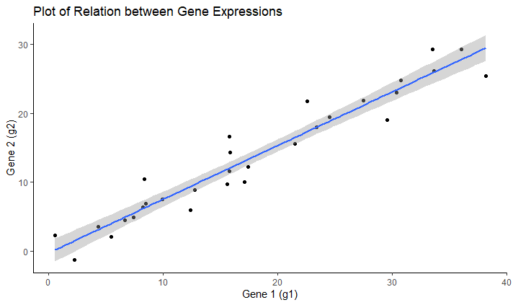

5) Chosen model is -> **y = bx**

After Linear regression, value of b = 0.76776

For our dataset, y = g2 and x = g1

Regressed equation of the fitted line -> **g2 = 0.76776*g1**

6) R-squared value = **0.9802**

7) Model used -> **y = bx**

P- value for coefficient of x is <**2e-16**

8) Regression is performed with reduced model **y = mx**

Statistical test results for the whole model **(y = mx + c)**

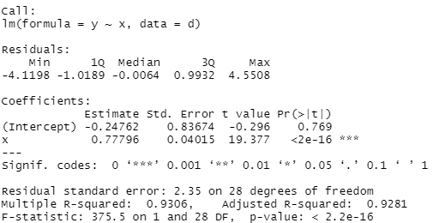

P – value for Coefficients of => Intercept -> **0.769**

x -> **<2e-16**

Since the p-value for intercept is much greater than our cutoff value of 0.05.

Therefore, we reject the model **y = mx + c.**

Now, Statistical test results for the reduced model **y = mx**

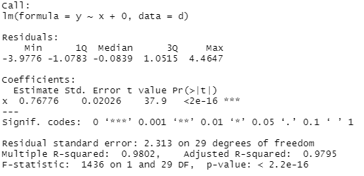

P – value for Coefficients of => x - **<2e-16**

Also Comparing the R-squared values for whole model and reduced model –

For whole model, R2 = 0.9306

For reduced model, R2 = 0.9802

Since R-squared value also increases and p-value for coefficients is below the cutoff of 0.05

We chose the reduced model for linear regression.